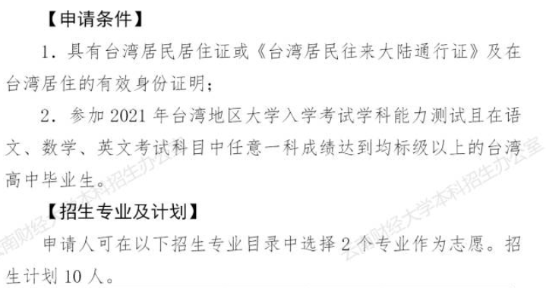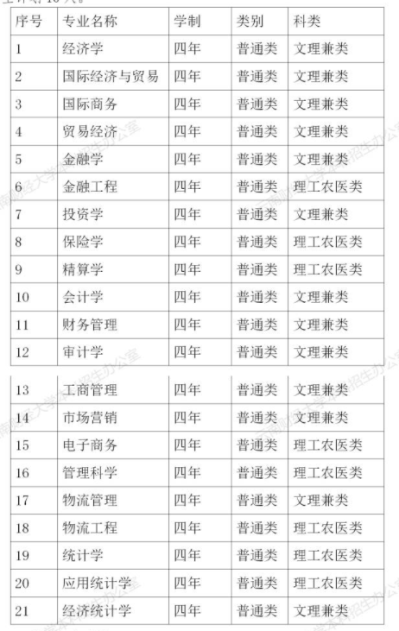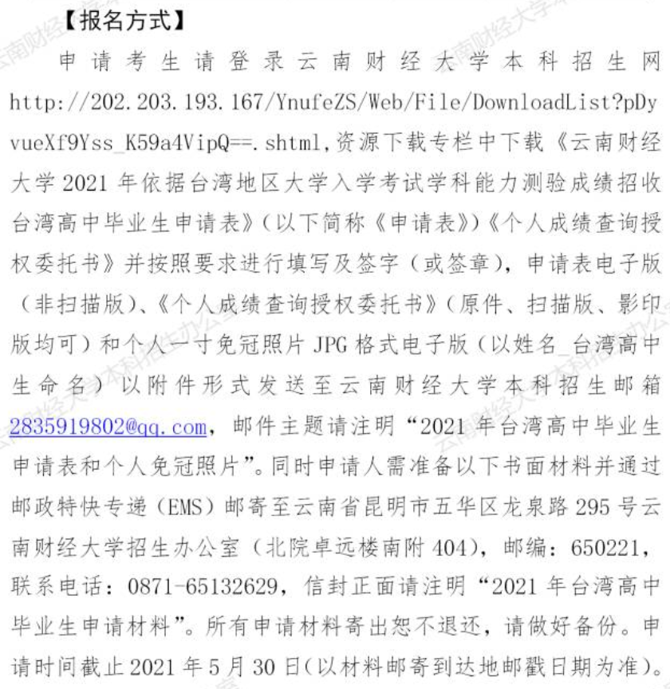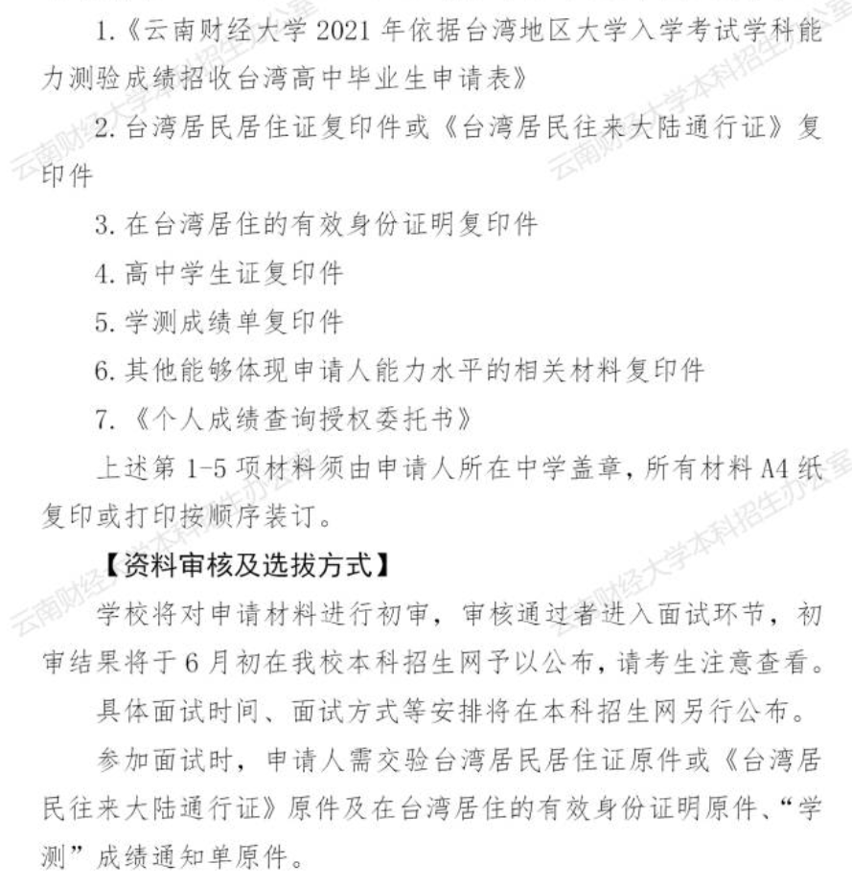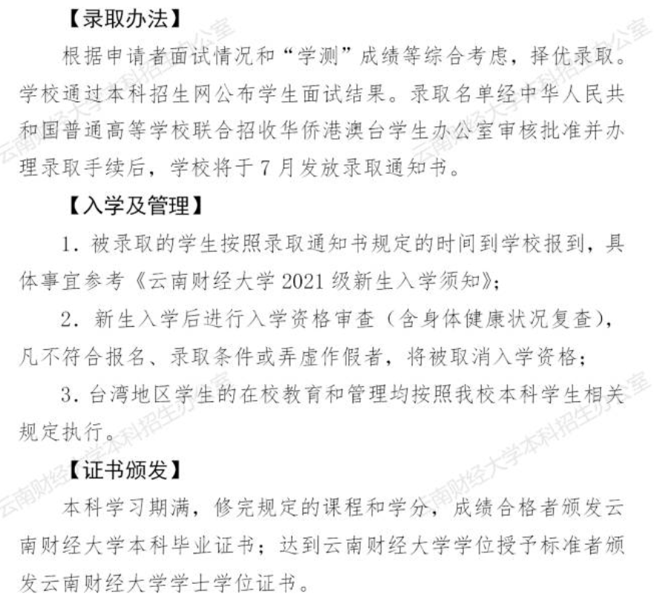
网址：http://202.203.193.167/YnufeZS/Web/Home/NewsDetail?gef5RrsU-lMiLalaihOwLJT2g9CJbttbXfADLZpchLg=.shtml

